Dalton Gilpatrick

10/20/2017

Comp. Methods: Project #1

This project was to build a material balance simulator that takes inputs such as pressure, compressibilities, saturations, productions, formation volume, and formation volume factors at an initial time, and outputs pressure and saturations at a later time after production has taken place. This was accomplished by using Newton’s method and Jacobian matrices. I coded this project in Microsoft Excel’s VBA language.

Convergence typically happened very rapidly, provided a good initial guess was provided and a reasonable tolerance. I usually just used the initial conditions as the guess, which produced quick results. The tolerance level, if set with too high a precision, would cause the program to run through all of its iterations once it had reached its minimum continuous residual result. The following are various charts designed to show the convergence given different conditions.

Typical chart set if the result converges:

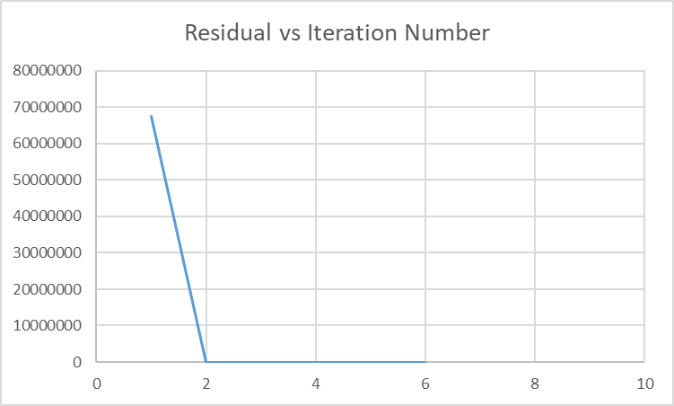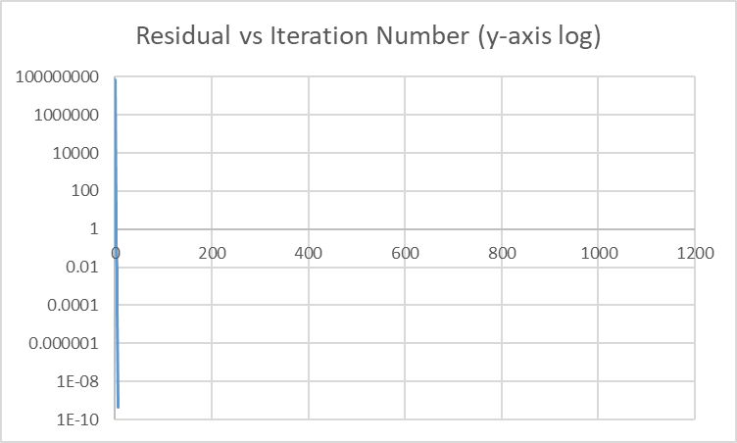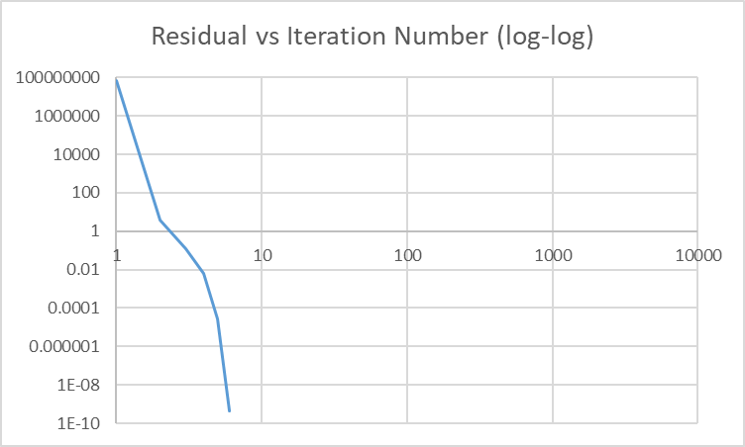

This shows that the method usually converges very quickly. For most circumstances, as long as a vaguely reasonable guess was given, the program converged.

The prior results were for compressible cases. Assuming that water, oil, and rock were incompressible, the program still converged very rapidly.

Graphs showing the convergence with incompressible rock, oil, and water:

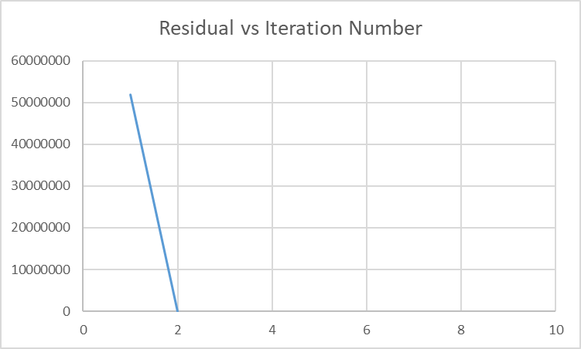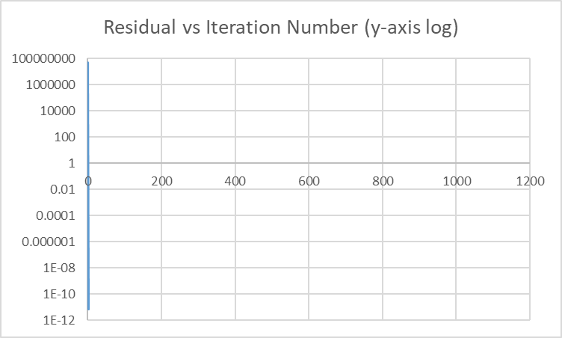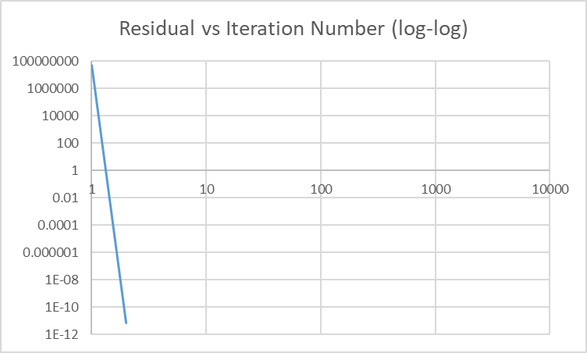

An interesting result happens when withdrawing almost all of what a reservoir has to offer. It is an extreme example, but it warrants attention. The program seems to be unable to arrive at a definitive conclusion where the residual would be below the tolerance threshold.

Graphs associated with extracting very large amounts of fluids:

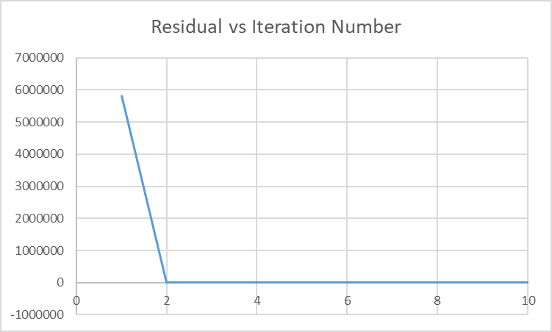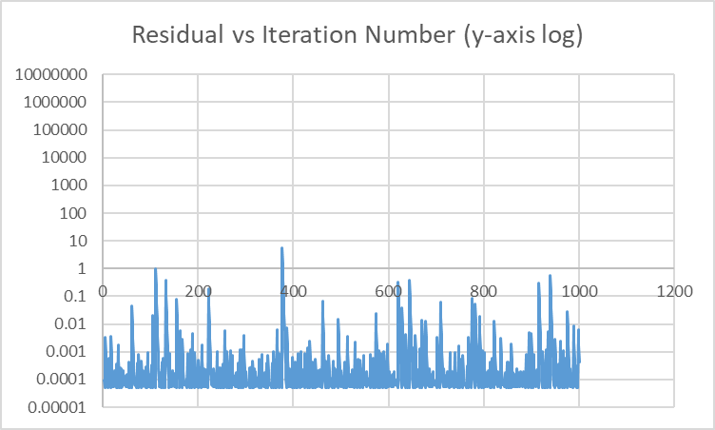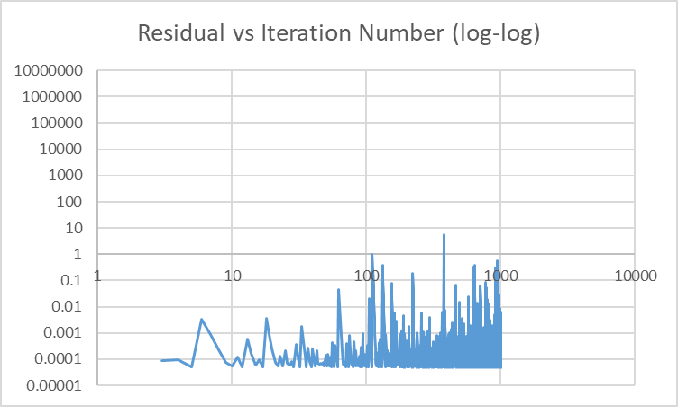

Overall, this programming exercise was very difficult, required extensive amounts of time and research to complete, but was satisfying to see work in the end. I believe that I have a better knowledge of how these types of programs now than I did before the project.